Kol Simcha Torah Gazette
For parshas pinchas 5786
Vol 10 Issue 38 (Whole #503) 19 Tammuz 5786/ July 4, 2026
Printed L’illuy nishmas Nechama bas R’ Noach, a”h
For a free subscription, please forward your request to keren18@juno.com
Past emails can be found on the website ShabbosStories.com under Brooklyn Torah Gazette
Judaism and Pet
Ownership: 18 FAQs
By Menachem Posner

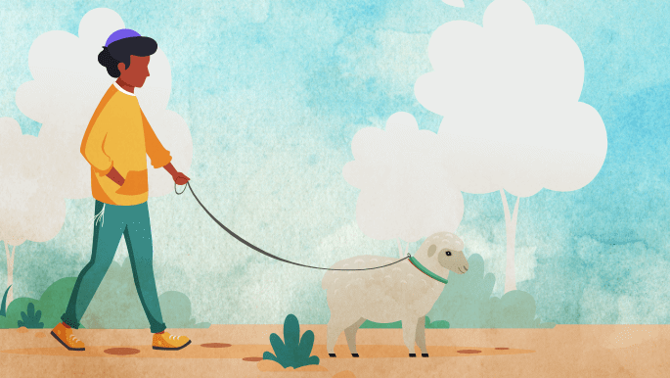
Art by Yitzchok Schmukler

According to polling data, between 50 and 70 percent of American households contain a pet. Presumably, this includes Jewish homes as well, which leads us to the question of Jewish law and tradition. In this article, we will explore some of the most frequently asked questions regarding Judaism and pet ownership.
May Jews own pets?
For a host of cultural reasons, anecdotal evidence suggests that Jewish homes did not often include pet dogs (although cats were more commonly kept, to keep mice at bay).
One reason for this may be that pets are generally non-kosher animals, and there is a preference for seeing kosher images to whatever degree possible.
Thus, Orthodox pet ownership is less common, and pet owners in some Orthodox neighborhoods may find themselves in the minority.
However, there is no Jewish law or tradition precluding pet ownership per se.
How about dangerous animals?
It is indeed forbidden to keep dangerous pets, such as a dog that bites (or even one who barks and frightens people), unless they are properly restrained. The Talmud and subsequent texts discuss what allowances may be made for security and what precautions are still necessary.¹
Is it OK to own a pig?
The Talmud tells us that there is an ancient curse placed on anyone who raises pigs. This happened after enemies besieging Jerusalem sent in a pig instead of the usual kosher animals that were allowed into the city to be sacrificed on the altar.²
So, although pigs make for intelligent and trainable pets, they are not right for Jewish homes.
How about neutering or spaying?
The gift of life is sacred. It is written “... in your land you shall not make” damage to an animal’s reproductive organs.³ It is, however, OK to purchase an animal that has already been fixed by a non-Jewish vet.⁴

Is it true that you need to feed animals before you eat?



In the Shema, we are assured that G-d will “give grass in the field for your cattle, and you will eat and be sated.⁵ From here the sages infer that we, too, must make sure that our animals have food before we sit down to breakfast.⁶
How about caring for pets on Shabbat?
There are indeed several issues pet owners need to be aware of regarding Shabbat:
“Trapping” is one of the 39 acts (melachot) forbidden on Shabbat. If your animal is prone to running away, then closing the door or window to prevent its flight may be a form of trapping.
It is permitted to walk your animal even outside of an eruv, provided that it is clear that you are walking your dog, not carrying the leash. This is accomplished by keeping the animals close to you, not letting the leash sag to within a handbreadth of the ground, and not letting a handbreadth of leash dangle from your hand. Carrying a bag for waste outside an eruv would also be an issue.
A conventional reading of Jewish law puts animals in the category of muktzeh, items that may not be handled on Shabbat. It has been argued, however, that household pets are not included in the category of muktzah at all, because they have an “immediate practical use.”⁷
Anything to know about the firstborn animals?
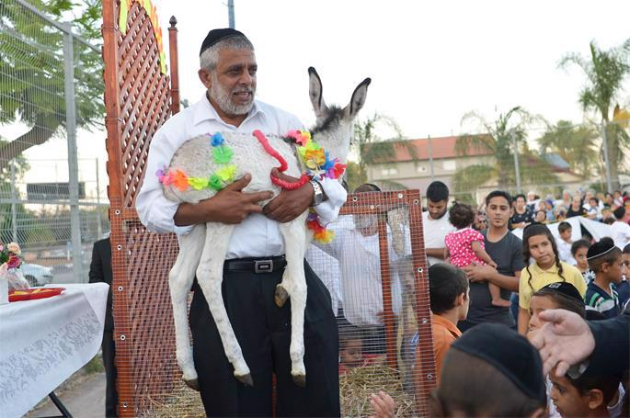
Redeeming the firstborn donkey, joyously carried out in Moshav Ahi'ezer near Lod on June 26, 2018. Photo by Yossi Zeliger/Flash90

We are told in the Torah that the firstborn of any kosher flock is holy and must be given to a Kohen (priest), who would consume it as a sacrifice in the Holy Temple. There is also a similar sacredness for the firstborn donkey, which must be exchanged for a sheep, which is then sacrificed. Nowadays, since there is no Holy Temple, firstborns cannot be sacrificed but must be allowed to graze until they become disqualified from being sacrificed due to physical blemishes. If you are raising kosher livestock or donkeys, consult your rabbi on the specifics of how this is to be carried out. There is nothing special about firstborn cats, dogs, hamsters, gerbils or goldfish.
Does my animal need to keep kosher?
Assuming that you are not preparing your animal’s meals in your kosher kitchen with your kosher dishes, your animal is free to enjoy horse meat or other non-kosher foods. An exception⁸ to this rule would be a cooked mixture of milk and meat, from which we may not benefit and are therefore not even allowed to feed our pets. This applies only to the meat of kosher land species. One may feed their pets milk cooked together with the meat of non-kosher animals or even kosher birds (such as chicken), as well as meat of a kosher animal that has been mixed but not cooked with milk,⁹ taking care, of course, not to get it on their kosher dishes.
What can I feed my pets on Passover?
Passover can be tricky, since we may not benefit from chametz on Passover. The ingredients of various animal foods are different, so consult the most recent guides published by your local kosher supervisory agency to find out what’s OK each year.
Note that kitniyot (beans, legumes, corn, etc.) may be fed to our pets, even by Ashkenazim who do not eat these foods on Passover.
Must a Jewish-owned pet fast on Yom Kippur?
We read on Yom Kippur afternoon how Jonah inspired the residents of Ninveh to fast and repent. In that case, as decreed by the king, both people and livestock refrained from eating and drinking.¹⁰ This, however, is not the Jewish way. On Jewish fast days, only Jewish adults (and children who are up to the task) are obligated to fast.
This does not include pets. In fact, in some instances, not feeding your pet would constitute tzaar baalei chayim, causing unnecessary pain to an animal, which is forbidden (see below).

What does Torah say about causing animals pain?
The Torah has several precepts relating to not causing animals unnecessary pain (tzaar baalei chayim), including the requirement to assist a struggling pack animal.¹¹
Now, when there is reasonable purpose for humans, Judaism does allow causing an animal discomfort. Thus, we slaughter animals to eat their meat, use their hides, and other purposes. However, plucking feathers from a living goose is sadistic and forbidden, even though those feathers will be used, since you can easily obtain feathers from animals that are no longer alive.¹²
May we put our elderly pets to sleep?
Since ending the life of an animal is permitted and causing pain to an animal is forbidden, euthanasia is a fine, humane option to consider when an animal is nearing the end of its life and is suffering.

Do pets go to heaven?
On a most simple level, heaven is a reward for good behavior and compensation for suffering endured here on earth. Since the Middle Ages, the Jewish sages have debated whether reward and punishment applies to animals.
Since no one on our staff can recall going to heaven and back, we cannot tell you for certain whether there is a doggie kennel there. But we do have a great article that cites the classic approaches to this issue:
Is there a Jewish tradition about animal funerals?
It is interesting to note that Judaism records an instance of animals themselves burying their dead. After Cain killed Abel, he wondered what to do with the body. Observing birds burying a fellow bird, he decided to do the same.¹³
However, the mitzvah to bury the dead is unique to humans. As G-d told Adam, “For dust you are, and to dust you shall return.”¹⁴ It stands to reason that this is unique to humans, whom G-d fashioned from dust.¹⁵
What to say when a pet dies?
When a person’s animal dies, the proper response is hamakom yemale lecha chisronecha, “May the Omnipresent fill your void.”¹⁶

Can I say Kaddish for my departed pet?

Art by Rivka Korf Studio

Our pets are a major part of our lives. However, there is no precedent in Jewish tradition for saying Kaddish for our pets.
There is little direct discussion of the permissibility of bringing pets into the synagogue from the Talmudic sages. The reason is obvious: In those days, animals were not used as pets.
Now, synagogues are a place for people (not animals) to pray. So, your pet has no reason to attend, as far as it is concerned. However, if your attendance depends on your pet being there with you (as discussed below regarding support animals), there may be room for exception, and the final ruling would depend on the determination made by the community rabbi.

How about bringing service animals to synagogue services?
In the mid-20th century, debate broke out regarding the permissibility of blind people bringing service dogs into the sanctuary. Rabbi Moshe Feinstein, a preeminent halachic authority in the US, allowed it,¹⁷ and Rabbi Menachem Kasher, a scholar in Israel, prohibited it.¹⁸
In an exchange of letters with Rabbi Kasher, the Lubavitcher Rebbe defended Rabbi Feinstein’s opinion, arguing that they should surely be allowed, as facilitating synagogue attendance for blind people is a worthy cause, and leniencies should be sought.

Footnotes
1. Bava Kamma 83a; Shulchan Aruch Harav, Shemirat Haguf Vehanefesh 3.
2. Bava Kamma 82b. 3. Leviticus 22:24
4. For more on this complex subject, see Shulchan Aruch, Even Ha’ezer 5:11-14.
5. Deuteronomy 11:15. 6. Gittin 62a.
7. Rabbi Moshe Feinstein (Responsa Igrot Moshe, Orach Chaim vol. 5, responsa 22)
8. There is a longstanding disagreement whether it is also forbidden to benefit from wine (or grape juice) of a non-Jew (see Code of Jewish Law, Yoreh De’ah 123:1. Since neither cat nor dog food contains grapes, this issue appears to be moot.
9. Code of Jewish Law, Yoreh De’ah 87:3. 10. Jonah 2:7-8. 11. See discussion in Bava Metzia 32b. 12. Kitzur Shulchan Aruch 191:1 13. Tanchumah, Genesis 10.
14. Genesis 3:19. 15. Genesis 2:7. 16. Berachot 16b. 17. Igrot Moshe, Orach Chaim 1:45. 18. Torah Sheleimah vol. 15 p. 147.

Reprinted from the current website of Chabad.Org

The Legacy of the Righteous
Daughters of Tzelafchad Who
Overcame the “Seemingly Impossible”
From the Teachings of the Lubavitcher Rebbe
Rabbi Menachem Mendel Schneerson, Zt”l


In this week's Torah portion, Pinchas, an incident with the five daughters of Tzelafchad is related. Tzelafchad, an Israelite who died in the desert, had no sons. Only sons were entitled to an inheritance; therefore, the daughters of Tzelafchad were not permitted a portion in the Holy Land.

Wanted to Have a Part in the Land of Israel
The daughters of Tzelafchad, who were all known to be righteous women, objected to the thought that their family would not have a part in the land of Israel. They went before Moshe, who presented the case to G-d. G-d said to Moshe, "The daughters of Tzelafchad speak right. You shall surely give them a possession of an inheritance among their father's brethren" (Numbers 27:7).
The above-mentioned episode is just one example in the Torah of the relationship of the Jewish women to the Land of Israel.
When the spies returned from the land of Canaan with reports of fortified cities, armies, and giants, the men decided to turn back to Egypt. But the women remained steadfast in their desire to enter the land. Consequently, only the men of military age were punished; they were to die in the desert. The women, however, entered the Land.

Descendants of the Tribe of Menashe
Tzelafchad's daughters were descendants of the tribe of Menashe, who had asked Moshe for permission to settle on the eastern side of the Jordan. They could easily have obtained land on that side, since the land there was distributed through Moshe personally. But, they were not content with such a portion. They loved the Holy Land and wanted a share in it.
The task they had set for themselves was not easy. The established judicial system was comprised of judges over fifty, one hundred, one thousand, etc. The daughters had to approach various judges, each one referring the matter to higher authorities until it was finally brought to Moshe, himself.
Tzelafchad's daughters were willing to try to overcome such a seemingly impossible and tiring obstacle to receive their portion.

Learning a Lesson for Our Daily Lives
This incident can serve as a lesson to us in our daily lives, too. G-d demands that we conduct our lives according to certain guidelines. Yet at the same time, He created and organized the universe in such a way that it seems to preclude proper fulfillment of our obligations of Torah study and performance of mitzvot.
But, with the right approach, we too, can merit a portion in our rightful inheritance. We must be willing to try to overcome the seemingly "impossible" obstacles, just as Tzelafchad's daughters did. If we undertake it with the same attitude of love as Tzelafchad's daughters, then certainly we will achieve our goal.

Reprinted from the Parshat Pinchas 5763/2003 (Issue #778) email of L’Chaim, a publication of the Lubavitch Youth Organization in Brooklyn, NY. Adapted from the works of the Lubavitcher Rebbe.

Rav Avigdor Miller on
The Venus Fly Trap

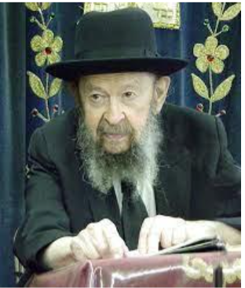

QUESTION: How does the age of the cavemen and the dinosaurs fit in with Torah?
ANSWER: And the answer is, how does the age of the computers fit in with the Torah? Any contradiction? No. Same is just like computers are contemporary with us, so were cavemen contemporary with dinosaurs. Only that today we are contemporary with computers, and yesterday people were contemporary with dinosaurs. The dinosaurs are quite recent.
And the fact is, if you want to spend money you can buy a film strip, you can rent it too if you want – I’ll give you the address where it can be procured – and you’ll see there, photographed footsteps, its fossilized footsteps, where you see a dinosaur waddling. Its footsteps are imprinted forever on a rock, and together with his footsteps are footsteps of a man. Human footsteps! Which means that the dinosaur was contemporary with man. Now that doesn’t fit according to the timetables of the evolutionists, but it’s proven, so what can you do?!
Now, the cavemen? There’s no problem there at all. Cavemen, that’s a silly thing. Because there are cavemen even today. In North Africa, even fifty years ago, when Nochum Sloush was traveling in North Africa, he found Jews living in caves in parts of North Africa. There was a place in the mountains where caves were available and didn’t cost any rent. So, hundreds and hundreds of Jews lived in caves. What does that mean, what does that prove? They’re putting on tefillin in the caves and eating matzah on Pesach in the caves and saying Bereishis barah Elokim in the caves as well. So, a caveman means nothing.

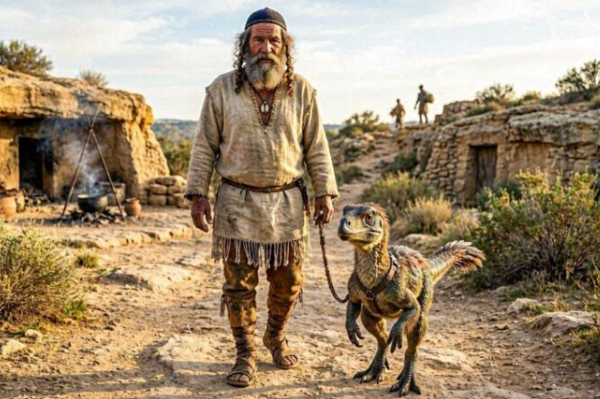

Now dinosaurs, that’s what puts a thrill in little boys who are taught evolution. And therefore, you have to know, dinosaurs are just the same as caveman. Because dinosaurs are a recent phenomenon. They went out of existence as soon as the Mabul took place. A great many of the huge lizards of antiquity that were not able to survive the flood, they were all destroyed in massive catastrophes. And that’s proven by the fact that you find dinosaur graveyards. Huge masses of dinosaur bones are jammed together in certain places as if they were buried together.
And that could only be due to catastrophe. They didn’t come and decide to bury themselves together. It’s not like a Montefiore Cemetery where every person applies for a grave. No! It was a catastrophe that swept them up suddenly. When the Mabul came there were great changes in the weather suddenly. Tremendous changes took place. When so much water is subtracted from the sea’s surface, there’s a tremendous change in the climate.
And in certain places the dinosaurs were immediately overwhelmed. They were frozen. You find thousands of mastodon skeletons in Siberia. In great cemeteries, great graveyards all buried together. Because there was a big catastrophe that engulfed them suddenly. And therefore, the dinosaurs and the cavemen and whatever else you have are no contradiction to anything that we teach in the Torah.

Reprinted from a recent email of Torah Avigdor based on a question-and-answer session at the end of a January 1984 classic Thursday night hashkafah lecture of Rav Avigdor Miller, zt”l.
Thoughts that Count
for Our Parsha

My sacrifice...you shall observe to offer to me in its time (Num. 28:2)
The Hebrew word used here for "observe" is often used to imply hopeful anticipation of a future happening. Though we do not have the opportunity to observe the laws of sacrifice while in exile, our constant anticipation and hope for the rebuilding of the Temple gives us a portion in the sacrifices which were previously offered there. (Sefat Emet)

Let the L-rd, the G-d of all living souls, appoint a man over the congregation (Num. 27:16)
Rashi explains that Moses was asking G-d to appoint a leader who would be able to understand each person according to that person's needs. Moses referred to G-d as the "G-d of all living souls." This was to underline that the leader should be one who loves all Jews in an equal and fair manner, regardless of their fear of G-d, or position. (Kedushat Levi)

And the Children of Korach did not die (26:11)
They did not die, and in every generation Korach's "inheritors" - those who rebel against the Moses of that generation - are alive and well, continuing in his path. (Sefer HaSichot)

My sacrifice ... you shall keep to offer to Me in its season (28:2)
Keeping something, as in "you shall keep" implies waiting for or anticipating something. Thus, are we able to keep the commandments of the sacrifices even in Exile, after the Holy Temple has been destroyed. We "keep" the laws associated with the Holy Temple by anticipating its rebuilding. Through our great longing for the Temple, we have a part in the sacrifices that were brought in those times. (Sfat Emet)

Reprinted from the Parshat Pinchas 5763/2003 (Issue #778) email of L’Chaim, a publication of the Lubavitch Youth Organization in Brooklyn, NY.

Seven Pearls of Wisdom
from a 102-Year-Old Holocaust Survivor
By Sofya Tamarkin


Pearl Hinda just turned 102 years old, survived the Holocaust, and rebuilt her life from nothing. Here are the seven lessons she wants you to know.

Born in 1924, Pearl Hinda Nagel endured unimaginable suffering. She lost her father as a child and her mother in the Lodz Ghetto. She survived forced labor, hunger, and the concentration camps, and then rebuilt a family and a life from nothing.
Having witnessed both the worst and the best of humanity, she believes that kindness is the greatest legacy any person can leave behind.
As Pearl Hinda celebrates her 102nd birthday and begins her 103rd year of life, she offers timeless wisdom earned through resilience, faith, and a lifetime of rebuilding.

1. Hope is a decision.
Pearl Hinda had every reason to surrender to despair. Instead, she chose hope every day. Even in the labor camp, she believed G-d had not abandoned her. Hope became the strength that carried her through the darkest moments.

2. Kindness costs nothing but can save everything.
Despite living with constant hunger, she shared her soup with another girl who needed it even more. After experiencing horrific cruelty, she refused to let it define her.

3. Don’t let your past become your destination.
After the war, Pearl Hinda returned to her old apartment building. The janitor’s wife gently urged her not to go upstairs because it would pull her back into the past. She carried her memories with her, but she chose to build a future instead of remaining trapped by yesterday.

4. Faith can sustain you when nothing else remains.
Orphaned, alone, and surrounded by death, Pearl Hinda maintained an unwavering connection to G-d. Her faith became an anchor when everything else had been taken away.

5. The best revenge is a life fully lived.
The Nazis tried to wipe out the Jewish people and erase Jewish life. Pearl Hinda answered by marrying, raising children, welcoming grandchildren and great-grandchildren, and passing on her faith and values. Every new generation became her greatest victory.

6. Time is life’s most precious gift.
As she begins her 103rd year, Pearl Hinda says she understands the value of time more than ever. Life is precious because no one knows how much of it we are given. Cherish your loved ones, do good while you can, and never take a single day for granted.

7. Joy is possible after unfathomable pain.
Suffering does not have to define the rest of your life. After losing nearly everything, she still speaks about gratitude, family, and hope. While you cannot choose every chapter of your life story, you can choose how to write the continuation of the story.
Pearl Hinda reminds us that purpose does not retire with age. As long as you are alive, you have something to give, someone to inspire, and a responsibility to make the world a little kinder than you found it.
Pearl shares this final thought: "I have tried to teach my children and grandchildren to be proud Jews and proud Americans. Unfortunately, the free world has not learned the lessons of the past and continues to support those who seek our destruction. I want my children and grandchildren to understand the gifts Jews and Israel continue to give to the world.
However, It is not wise to ignore the rampant antisemitism which is worldwide. But we have an amazing Jewish state. As proud, resilient people, we will never again have a Yad Vashem erected to our memory."
Happy 102nd birthday, Pearl Hinda!

Reprinted from the current website of aish.com

The “Blessed” Accident
A Jewish man was walking down the street when he was struck by a speeding car. He was severely injured and lost so much blood that he fell unconscious. Hatzolah came and took him to the hospital. He was rushed to an operating room for emergency surgery. When he awoke, the head doctor came to visit him. The Jew asked how the surgery had gone, and the doctor answered with tears in his eyes, “If I hadn’t personally witnessed this miracle, I never would have believed it. The operation was much more successful that what I could possibly have imagined in my wildest dreams.”
He continued, “When they brought you here, your condition was very bad. I had you brought immediately to the operating room and, in the middle of the surgery, it was discovered that you had a cancerous growth in your stomach. During that surgery, we removed the growth, which was still small and hadn’t started spreading yet. Now you are fully healthy.” The doctor concluded, “This accident saved your life. If the growth hadn’t been found in time, we wouldn’t have been able to do anything for you, and you would have died young. You should thank G-d for this accident!”

Reprinted from the Parshas Pinchas 5786 email of The Way of Emunah: Collected Thoughts on the Weekly Parshah from Rabbi Meir Isamar Rosenbaum.

